BIOGRAPHY
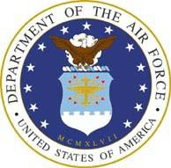

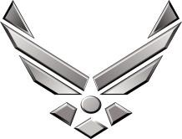

U N I T E D S T A T E S A I R F O R C E

COLONEL KELVIN D. MCELROY
Col. Kelvin D. McElroy is the Mobilization Assistant to the Director of Logistics, Civil Engineering, Force Protection and Nuclear Integration, Headquarters Air Force Materiel Command, Wright-Patterson AFB, Ohio. He directs policy and procedures for field and depot-level aircraft and commodities maintenance, nuclear weapon systems sustainment, software engineering, conventional munitions, logistics plans, transportation, supply chain operations and management, civil engineering, force protection and logistics information technology activities. As the lead command integrator for life cycle sustainment, he plans and coordinates product support and acquisition logistics across the Air Force weapon systems portfolio.
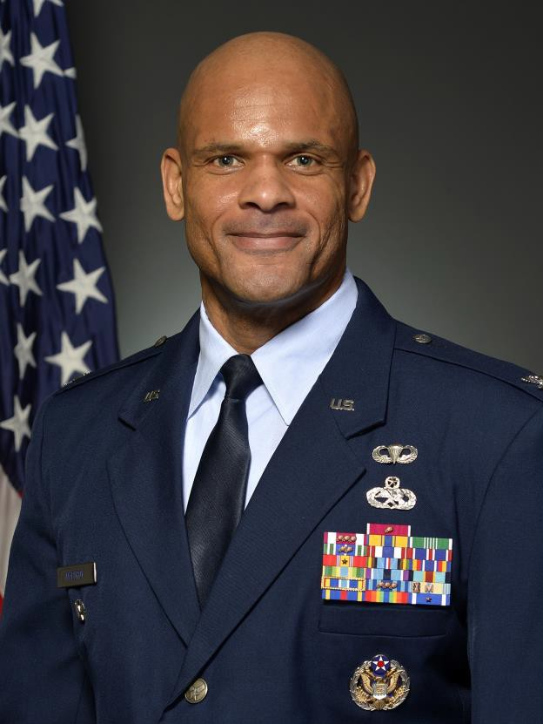

Colonel McElroy was commissioned as a second lieutenant in the U.S. Army in June 1994 through the Army Reserve Officer Training Program at Fort Valley State University, Ga. While on active duty, he served as an air defense artillery officer before joining the Air Force Reserve in 2000. Since joining the Reserve, he has held numerous positions including chief of supply and fuels, Air Force ROTC instructor, deputy of war fighter logistics and maintenance squadron commander. He previously served as the commander of the 914 th Maintenance Group, Niagara
Falls, Air Reserve Station, N.Y., commander of the 512th
Maintenance Group, Dover Air Force Base, Dover, Del, the
Director, Logistics, Engineering and Force Protection, 22nd Air Force, Dobbins Air Reserve Base, Marietta, Ga. and Associate Director Logistics and Reserve Advisor to the Deputy Chief of Staff for Logistics, Engineering and Force Protection, Headquarters U.S. Air Force, Washington, D.C. Prior to this current assignment, he served as the MA to the Commander, Oklahoma City Air Logistics Complex, Tinker AFB, Okla.

EDUCATION
1994 Bachelor of Arts degree in business administration, Fort Valley State University, Ga 2001 Squadron Officer School, Maxwell AFB, Ala
2001 Master of Applied Social Science - public administration, Florida A&M University, Tallahassee, Fla 2004 Air Command and Staff College, by seminar
2009 Master of Science in National Resource Strategy, The Dwight D. Eisenhower School, National Defense University, Washington D.C.
2016 Leadership Development Program, Center for Creative Leadership, Colorado Springs, Co 2016 Enterprise Perspective Seminar, Alan Freed Associates, Washington D.C.
2017 Strategic Mindset Seminar, Stimson Associates, Washington D.C.

2017 Reserve Component National Security Course, National Defense University, Fort McNair, Washington D.C.
2018 Transnational Issues Seminar, Alan Freed Associates, Washington D.C. 2020 Leading Strategically, Center for Creative Leadership, Colorado Springs, Co 2020 Data Science for Data Leadership, AGovX, Washington D.C.
2021 Joint Operational Contract Planning and Execution Course (JOPEC) Lite, Joint Staff, J-4, Washington D.C.
2021 Global/Regional Seminar: China, East Asia, Oceania, INDO-PACOM, Alan Freed Associates, Washington D.C.

ASSIGNMENTS
- June 1994 - January 1995, student, Officer Basic Course, Air Defense Artillery, Fort Bliss, Tx.
- February 1995 - February 1996, platoon leader, 5th Battalion, 5th ADA, Stringer Platoon, Republic of Korea
- March 1996 - November 1996, battle staff captain, 1-4 ADA, Tactical Operations Center, Bosnia-Herzegovina
- November 1996 - August 1997, battalion assistant operations officer, 1-4 ADA, 1st Armored Division, Germany
- August 1997 - December 1999, executive officer, Delta Battery, 1-4 ADA, Germany
- January 2000 - June 2003, chief, supply and fuels, 403rd Logistics Support Squadron, Keesler AFB, Miss.
- July 2003 - August 2004, deputy commander, 403rd Maintenance Group, Keesler AFB, Miss.
- August 2004 - July 2008, commander, 403rd Maintenance Squadron, Keesler AFB, Miss.
- August 2008 - June 2009, student, The Dwight D. Eisenhower School for National Security and Resource Strategy, National Defense University, Washington D.C.
- July 2009 - January 2012, commander, 914th Maintenance Group, Niagara Falls IAP ARS, N.Y
- May 2011 - November 2011, deputy commander, 379th Expeditionary Maintenance Group, Al Udeid Air Base, Qatar
- January 2012 - October 2014, commander, 512th Maintenance Group, Dover AFB, Del.
- October 2014 - July 2016, director, Logistics, Engineering and Force Protection, 22 Air Force, Dobbins ARB, Ga.
- July 2016 - September 2019, associate director logistics and reserve advisor to the deputy chief of staff for Logistics, Engineering and Force Protection, Headquarters U.S. Air Force, Washington, D.C.
- October 2019 – October 2021, MA to the Commander, Oklahoma City Air Logistics Complex, Tinker AFB, Okla.
- October 2021 – Present, MA to the Director of Logistics, Civil Engineering, Force Protection and Nuclear
Integration, Headquarters Air Force Materiel Command, Wright-Patterson AFB, Ohio.

MAJOR AWARDS AND DECORATIONS
Legion of Merit with two oak Leaf Clusters
Air Force Meritorious Service Medal with four oak leaf clusters Army Commendation Medal
Army Achievement Medal
Air Force Outstanding Unit Award
National Defense Service Medal with bronze star Armed Forces Expeditionary Medal
Global War on Terrorism Service Medal Armed Forces Service Medal Humanitarian Service Medal
Army Overseas Service Ribbon Air Force Longevity Service
Air Force Training Ribbon Army Service Ribbon NATO Medal

EFFECTIVE DATES OF PROMOTION
Second Lieutenant June 1, 1994
First Lieutenant June 1, 1996
Captain June 1, 1998
Major June 1, 2002
Lieutenant Colonel Aug. 2, 2007
Colonel Feb. 17, 2012 (Current as of Dec 2021)

